THE ‘SOUNDS OF THE DOLOMITES’ FESTIVAL IS RETURNING TO TRENTINO, ITALY
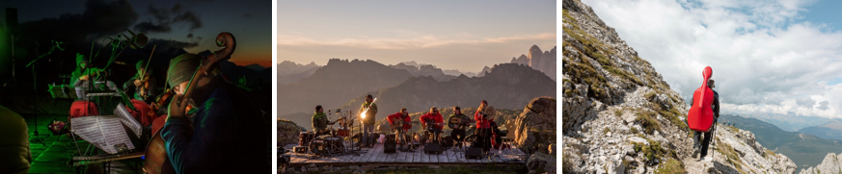
From 22 August to 23 September 2022 musicians and attendees can climb up soaring peaks to reach wide valleys, meadows & clearings which will be the stunning setting for multiple musical performances

Images can be downloaded here
The northern Italian region of Trentino is getting ready for an exciting month filled with the best international, classical, and jazz music concerts set amongst the beautiful Dolomites, now a UNESCO World Heritage Site. The anticipated festival, Sounds of the Dolomites will take place from 22 August to 23 September and will invite all music lovers to experience the mountains whilst listening to mesmerising melodies and soaking up the rich culture of the region.
Visitors and performers will climb a selection of paths in the Dolomites to reach the settings for the sixteen concerts; most performances are held at midday when the sun is at its peak, however, some concerts are held at dawn and are called Dawn in the Dolomites (6 September) and the music starts when the sun peeps through the ethereal mountains.
The festival was initially created to showcase the beauty of Trentino and to immerse visitors in nature and music. All concerts are free of charge, except the experiences that are held indoors and include special trekking projects, which are three-day packages, during which musicians and participants accompanied by the Trentino Alpine Guides share daily journeys to the mountains and offer exclusive concerts.
In addition, Trentino is packed with many exciting cultural events and exhibitions this summer:
The legendary and provocative street artist, Banksy, will also be the star of the season. Between 18 June and 9 October, Palazzo delle Albere in the city of Trento will host the exhibition “Un artista di nome Banksy” (“An artist called Banksy”).
From 14 May to 18 September, a monograph of one of the most well-known contemporary artists, Alex Katz, will be held at The Mart (Museum of Modern and Contemporary Art of Trento and Rovereto). The Alex Katz “Vita d’artista” exhibition will showcase a core selection of large and extra-large works which will match the museum’s architecture. Information on all the exhibitions at The Mart can be found, here.
Between May and September, train journeys to the most atmospheric castles in Val di Non and Val di Sole will be on offer for history buffs to truly experience what it was like to live in yester-year. An icon of international contemporary culture, Brian Eno, will also be creating an installation of infinite variations of shapes, lights, and sounds in different castles. Castello del Buonconsiglio will be home to four site-audio installations that will play music composed by Eno. The compositions will be ever-changing, offering attendees a continuously unique experience. Castel Beseno will become home to a unique visual art project involving the creation of two extraordinary, large-scale installations. The entire surface of the Castel Beseno’s walls and façades will be covered in Eno’s most famous visual works. More information on the fascinating project can be found, here.

For more information on culture in Trentino, please visit: www.visittrentino.info/en/experience/art-and-culture
For more information, news and stories, please visit: www.visittrentino.info/en/press

- Ends-
About Trentino:
Stretching from Lake Garda boasting a Mediterranean climate, up to the soaring Dolomites (a UNESCO World Heritage Site), Trentino is home to some of Italy’s most diverse terrain, with Alpine woodlands, almost 300 lakes, olive groves and green valleys, dotted with historic towns and villages. Trentino is easy to reach thanks to its central position between major northern Italian cities. Verona, Bergamo, Milan, Venice and Bologna airports are a one-two hour drive of Trentino. Long distance Italian and European trains serve Trento and Rovereto.
Media Enquiries:
Trentino Marketing is represented by LOTUS in the UK. Please contact Lydia Matthews and Dovile Stuknyte at trentino@wearelotus.co.uk or call +44 207 953 7470
For further info, please visit the Trentino media room: www.visittrentino.info/en

