WINTER IS NOT OVER IN TRENTINO:
ENJOY FOOD AND MUSIC ON THE SLOPES

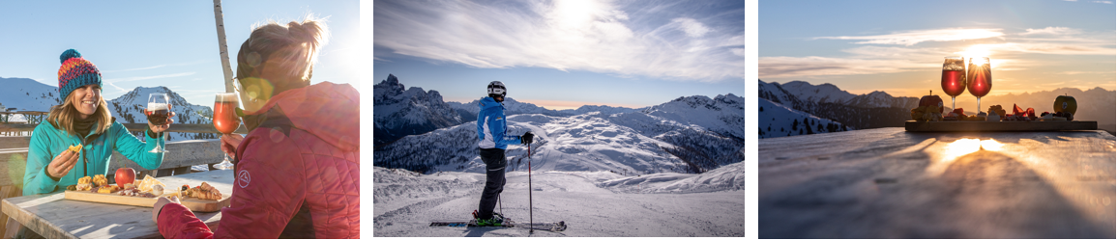

A sensational slurry of snow has once again covered the valleys of Trentino in northern Italy, which means one thing - winter is not yet leaving. The recent snowfall offers an extended chance to enjoy ski and winter activities and to experience the upcoming events taking place on the powdery slopes.

Winter is not planning to leave Trentino. Western ski resorts such as Brentonico, Monte Bondone, Paganella, the Madonna di Campiglio-Folgarida-Marilleva ski area, Passo Tonale and the eastern side of Trentino: San Martino di Castrozza, Val di Fiemme, Val di Fassa and Alpe Cimbra have all enjoyed a fresh dose of snow. Parts of the region such as Monte Bondone, Paganella and Madonna di Campiglio have experienced particularly intense snowfall with blankets reaching up to 30 - 40cm in thickness. The snow is expected to remain intact due to low weather temperatures lasting through February and March. This provides a great opportunity for winter sports enthusiasts to enjoy 800km of perfectly snow-covered tracks in the destination, for that last minute winter break.

There are also numerous events taking place in Trentino this February and March. The Dolomiti Ski Jazz Music Festival is held from 5 - 13 March in the Val di Fassa and Val di Fiemme ski valleys and will take jazz music lovers and ski enthusiasts to an unusual high-altitude location: the slopes.

In addition, the Val di Fiemme, Val di Fassa and San Martino di Castrozza areas in the Trentino Dolomites will see the return of the HappyCheese events taking place from 4 - 26 March 2022. Cheese lovers can enjoy aperitifs and local delicacies right in the heart of the Dolomites in one of the scenic mountain terraces or mountain huts. The cheeses can be sampled alongside a glass of the exquisite sparkling Trentodoc which is famous in the region or some local craft beer, straight off the slopes.

Finally, TrentinoSkiSunrise continues until 17 March and gives early birds the opportunity to make the first tracks of the day on the mountain whilst enjoying the awe-inspiring scenery at dawn. Sunrise seekers can enjoy a sumptuous breakfast in a traditional alpine ‘Rifugio’ before enjoying the fantastic new snow that has been sprinkled across Trentino.

Images available to download here.

Getting to Trentino

Trentino is easy to reach thanks to its central position between the Southern Alps, Venice in the north of Italy. Verona, Bergamo, Milan, Venice and Bologna airports are a one-two hour drive of Trentino. Long distance Italian and European trains serve Trento and Rovereto.

-Ends-
Media Enquiries:
Trentino Marketing is represented by LOTUS in the UK. Please contact Georgina Oakley and Lydia Matthews at trentino@wearelotus.co.uk or call +44 207 953 7470

For further info, please visit the Trentino media room: www.visittrentino.info/en/press.

