SLEEP UNDER THE STARS IN TRENTINO
Enjoy a slower pace of life with countless camping and glamping opportunities
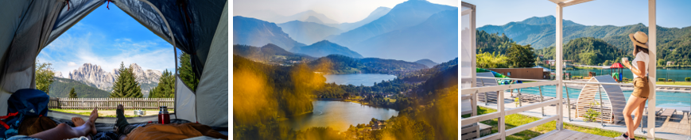

As winter is slowly coming to an end and days are getting longer and brighter, now is the right time to start planning a holiday to warmer climes. Italy’s mountainous region of Trentino is famous for its magnificent natural landscapes and is certainly the right place for all nature lovers who want to spend more time outdoors this spring/summer. The region boasts an array of activities such as trekking, hiking, canoeing, cycling and paragliding for both beginners and experts, that will help visitors to stay active and explore the region.
There is no better way to truly get under the skin of a destination and enjoy its natural beauty than choosing to camp in well-appointed campsites. Trentino is abundant with fantastic opportunities for camping and glamping set by its crystalline lakes, with bungalows, tent pitches, and loads of amenities, from swimming pools to wellness areas, winning several awards from important international associations and is a great alternative to hotels or guesthouses.

Camping Al Lago, located by the banks of Lake Garda, provides a nature-filled experience and includes an option to stay at different types of charming safari-style tents without the need to give up the comfort.
Campsite Camping Zoo located in historical Arco is a pet-friendly destination that now offers new glamping experiences with amenities such as 16mm2 Coco Tent, perfectly assembled and furnished like a tiny apartment, immersed in nature.
Lago Levico Camping Village, located in Valsugana, is the largest family campsite in the valley. The campsite is embracing a new camping experience and from 22 April, there will be different options of tents to choose from such as the two-level glamping tent with a view of the lake, as well as eco-friendly lodgings and mobile homes with furnished verandas.
Camping Spiaggia, overlooks Lake Molveno, the Most Beautiful Lake in Italy, according to the Italian Touring Club. Perfectly situated between the lake and the mountains, this site offers excellent amenities, especially for families, including the new Dolomia Wellness centre. Just outside the campsite, there is a hiking trail, leading into the Adamello Brenta National Park woods towards the peaks and the mountain huts of the mountain range or for an easy stroll around the lake.
Nearby in Val di Fassa, outdoor enthusiasts will find Camping Vidor which is a family and wellness resort. Built to look like an amphitheatre with views of vast woods and the stunning Dolomites on all sides. It is an excellent campsite for anyone looking for an active holiday outdoors. The trails to beautiful Val San Nicolò and the peaks of the Monzoni and Marmolada Group start just outside the campsite.

-Ends-
Media Enquiries:
Trentino Marketing is represented by LOTUS in the UK. Please contact Lydia Matthews and Dovile Stuknyte at trentino@wearelotus.co.uk or call +44 207 953 7470
For further info, please visit the Trentino media room: www.visittrentino.info/en/press.

