HIKING & BIKING IN TRENTINO THIS SUMMER
From 18 June, a network of trails covering more than 5,800 km in Trentino’s glorious mountains will once again burst with life thanks to the re-opening of almost all 140 Alpine huts
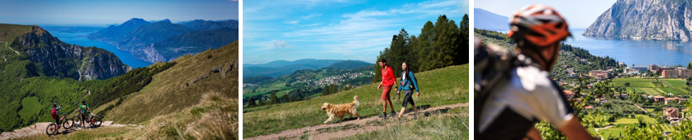
Images can be downloaded here.
Stretching from the northern shores of Lake Garda boasting a Mediterranean climate, up to the soaring Dolomites (a UNESCO World Heritage Site), Trentino has lots to offer; a beautiful and diverse landscape, crystalline lakes, historic towns and villages with a rich culinary heritage and active adventures and it is certainly the right place for all nature lovers who want to spend more time outdoors and enjoy the picturesque views.
There are many ways of getting to know Trentino, however, biking and hiking are highly recommended to get under the skin of the region in no time at all. Since biking and hiking are integral parts of Trentino, the lanes and trails are well looked after and are easy to navigate.

HIKING SEASON IS BACK

A two-day trial for families in Trentino can be found in the Val di Rabbi valley, which leads to the Rifugio Dorigoni mountain hut in Val Saènt before reaching the lake and Rifugio Lago Corvo, finally returning to Piazzola. The first day involves three hours of walking from the Malga Stablasolo farmstead to the hut, allowing hikers to admire the Val Saènt waterfalls on the way. The next day involves a crossing that climbs around 500 m, taking in the spectacular Cima Collecchio on the border between Trentino and Alto Adige before reaching Lake Corvo.

Another trail route that doesn’t require special preparation and all families will enjoy is located in Italian Alps of Fassa, and stretches from Val Contrin to Val San Nicolò. The trail starts at Alba and leads to historic Rifugio Contrin hut in around two hours. The next day, after admiring the dawn breaking over the southern face of the Marmolada, head towards the Rifugio Passo San Nicolò hut, where the descent to Val San Nicolò begins surrounded by the majestic peaks of the Marmolada Group, dotted with cabins, typical tabià’s, or barns.

This year is a special year for all outdoor activities fans of Trentino because The Society of Tridentini Alpinists (SAT) is celebrating its 150th anniversary. The society was established in 1872 (2 September) in Madonna di Campiglio with a noble goal in mind: to promote Trentino mountains, the tourist development of the valleys and Trentino’s culture.

CYCLE THE DOGA ROUTE

Stretching from the Brenta Dolomites to Lake Garda, the new DoGa (Dolomites-Garda) Alpine cycling route is 110 kilometres long and provides a unique way to visit the waterfalls as well as the greenest valleys of western Trentino. The cycling route can be tackled in one day or split into few days for a more leisurely journey so there’s enough time to visit and explore various villages, valleys and the Adamello-Brenta Nature Park.

DoGa begins in Malé, in Val di Sole, and goes all the way to the turquoise lakefront at Riva del Garda. It has two different cycling paths that cyclists can choose from according to cycling experience - a complete route, which is more complex or the “Dolce vita” route which cuts out the Daone Pass and is perfect if riders have had too many delicious aperitivos, offering fewer steep climbs.

VAL DI SOLE ON A GRAVEL BIKE

Cycle enthusiasts can discover Val di Sole Bikeland - an authentic paradise for bike lovers. The valley boasts many forest roads and paths that are perfect for gravel biking. There are many dedicated routes, extending approximately to 40 km with an altitude between 640 to 2,200 metres.
CYCLE IN ALPE CIMBRA
Discover the municipalities of Lavarone and Folgaria, cycling through all the areas of the Oltresommo. This route connects Mount Cornetto with Lake Lavarone, which has been awarded a Blue Flag certificate and is a very popular destination during the hot summer months to relax and enjoy activities on the water. The route also connects all the hamlets of Oltresommo, passing through Noselari, Carbonare, Cueli, Liberi, Tezeli, Perpruneri, San Sebastiano, Morganti, Virti and Parà di Sopra.

- ENDS -

Media Enquiries:
Trentino Marketing is represented by LOTUS in the UK. Please contact Lydia Matthews and Dovile Stuknyte at trentino@wearelotus.co.uk or call +44 207 953 7470
For further info, please visit the Trentino media room: www.visittrentino.info/en

